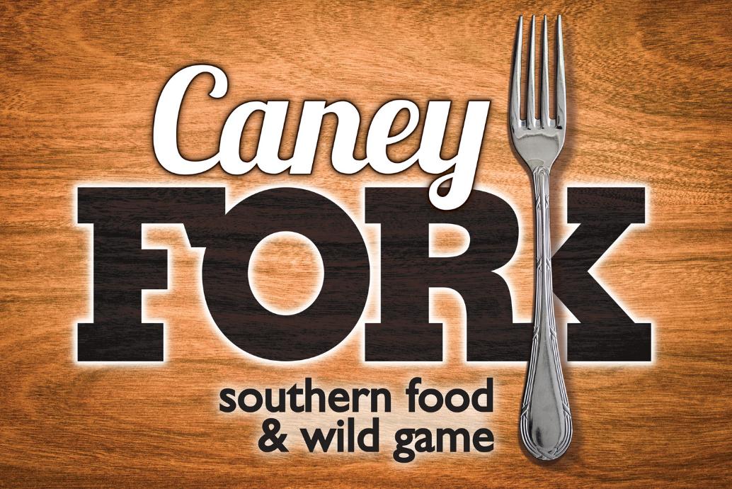

2400 Music Valley Drive Nashville TN, 37214

(615) 724-1200

Private Dining Room

The Private Dining Room available at Caney Fork is perfect for your next meeting or family gathering such as wedding reception, rehearsal dinner, anniversary, or family reunion.

Amenities (All amenities should be expressed to party coordinator at time of booking.)
- Private
- Wheelchair Accessible
- Fully Enclosed
- Speakers
- Built in Fish Tank
- Private Entrance

Parties of 20 or Under
- Separate checks are allowed, up to 10 separate checks per party.

Set Menu Option for groups of 20 or more

By having meal selections in advance, we can ensure an extraordinary experience. Here at Caney Fork, we prepare and serve our food to-order-fresh and never frozen, to create an incredible meal, every time. Please select one package and provide an exact menu count 5 days prior to the party date. Each guest only needs to pick one protein from the option of your choice. All entrees are served with your choice of soda, freshly brewed tea, or coffee (free refills). You start off with your choice of either a green salad or casear salad. The entrée selection will come with set sides. Peach cobbler can be added on for dessert for an up-charge. Menu options are listed below. Alcohol is not included but can be added. Taxes and gratuity not included.

SOUTHERN SUPPER (CHOICE ONE)

FRIED CATFISH FILET
Mississippi’s finest farm raised catfish filet served with coleslaw,
white beans and hushpuppies.

GRILLED CHICKEN
An eight-ounce chicken breast grilled to perfection and served with baked beans and coleslaw.

CHOP STEAK

Hickory grilled and topped with onions, mushrooms, and brown gravy, served with baked beans and coleslaw. *All chopped steaks are cooked MW unless specified differently.

CAJUN FEAST (CHOICE TWO)

FRIED CATFISH FILET
Mississippi’s finest farm raised catfish filet served with coleslaw,
white beans and hushpuppies.

SIMPLY CANEY CHICKEN
An eight-ounce chicken breast grilled to perfection, topped with bacon, pepperjack cheese, mushroom, onions, and honey mustard. Served with baked beans and coleslaw.

Hunters Cut Pork Chop
A juicy Bone-In, antibiotic free, and marinated in our house mix for 24hrs.
Served with baked beans and coleslaw
*All Pork Chops are cooked MW unless specified differently.

RIVER PACKAGE (CHOICE THREE)

FRIED CATFISH FILETS
Two pieces of Mississippi’s finest farm raised catfish; served fried with coleslaw, white beans, and hushpuppies.
ROASTED CHICKEN
½ a chicken covered in our secret seasoning, roasted slowly to capture the moisture and flavor, and served with baked beans and coleslaw.
HICKORY-SMOKED RIBS
A half-slab of our famous, slow-cooked & basted ribs; served with
coleslaw and baked beans.

*$2.00 per person with a “Sweet Ending” of Peach Cobbler, or $4.00 per person one scoop of
ice-cream from Mimis Ice-cream next door.

Buffet or family style options are available but will be additional cost.

Other considerations (additional charges may apply):
- Appetizers as guests arrive
- Champagne Toast ($2.00 per person)
- Cake Cutting ($1.50 per guest)
- Wine by the Bottle, before arrival or during event.
- Full-service bar, open bar or cash bar (Bar options listed below)

Pre-Paid Bar Tab
Host may select a dollar amount that is allotted to Beverage Consumption. When bar tab limit is met, host can elect to increase the tab or guests will become responsible for any additional drink purchases individually.
Our events coordinator will reach out to finalize price

Well Open Bar
Guests can enjoy an unlimited amount of cocktails made with well brand alcohol, in addition to select domestic beer and house wine.
Must be purchased for every guest of legal age if selected for the event
Requires a minimum of 2 Hours
Ask your event assistant about special pricing for longer events or to select a custom length for your open bar
$$Depends on day and event
(2 HOURS)
Alcohol on Consumption
Host pays for what is consumed. Drinks are tallied during the event and charged to host's card on file post-event.
Calculated at Event
Cash Bar
Guests are responsible for the purchase of their own beverages
Paid By Guests

Domestic Beer & Wine Open Bar
Guests can enjoy an unlimited amount of select domestic bottle or draft beer and house wine.
Must be purchased for every guest of legal age if selected for the event
Requires a minimum of 2 Hours
Ask your event assistant about special pricing for longer events or to select a custom length for your open bar
$$Price depends on day and event
Call Open Bar
Guests can enjoy an unlimited amount of cocktails made with call brand alcohol, in addition to select domestic beer and house wine.
Must be purchased for every guest of legal age if selected for the event
Requires a minimum of 2 Hours
Ask your event assistant about special pricing for longer events or to select a custom length for your open bar
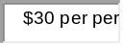
(2.5 HOURS)
(2 HOURS)
Bar Tab
Host may select a dollar amount that is allotted to Beverage Consumption. When bar tab limit is met, host can elect to increase the tab or guests will become responsible for any additional drink purchases individually.
Our events coordinator will reach out to finalize price
PAYMENT

A $100.00 non-refundable reservation booking fee is due by credit card at the time of booking. This fee is a onetime only payment that does not go towards the bill. It goes towards all the extra hands we have helping to make sure your party goes as perfect as possible

IF YOU USE A CREDIT CARD, YOU WILL BE CHARGED AN ADDITIONAL 3% SURCHARGE. Sales tax also applies. When you pay cash or debit this charge does NOT apply! You must add a credit card on file to hold your date, so that we can confirm the card is valid. No party date or times are saved until your credit has been added. Final guest count and menu selections are due 5 business days before the event. We will not charge your card for the final payment until final guest count and menu selections are made.
- Any payment still owed at the time of the event must be paid by host in-full at the event unless other arrangements are agreed upon with documentation prior to the event.
- Any additional on-site consumption beyond the prepaid portion will be automatically charged to the card on file post-event at manager’s discretion unless other arrangements are made in advance.
- Failure to submit timely payment may result in penalty.

CANCELLATION POLICY
- Events cancelled more than 30 days before: No penalty for cancelling.
- Event cancelled 30 days or less before the event: A $200 cancellation fee will be automatically charged to the credit card on file.
- The cancellation fee is non-refundable.
- The Final Payment is non-refundable.
- The booking fee is non-refundable.

GUEST COUNT
- The final guest count is a minimum guarantee required to be reported according to the payment policies.
- The customer will be charged, at minimum, for the number of guests specified in the final guest count.
- If the number of guests exceeds the final guest count, the final bill will be increased accordingly.

MENU SELECTION
- The final menu selections are required to be reported one week ahead according to the payment policies. Need each guest to choose a protein from one of the meal packages one week before event.
- Some menu items and pricing are subject to change bases on availability and seasonality.

ENTERTAINERS
- Management must approve all entertainment before the event to ensure it meets with noise regulation, space requirements and does not cause disruption to other patrons in the restaurant.

OUTSIDE FOOD & BEVERAGE
- No food or beverage of any kind may be brought in by the Customer without prior approval from the management. Additional fees may apply.
- Outside desserts can be brought in for an event for an additional fee. Please be aware of our $1.50 per guest Cake Cutting Fee.

SALES TAX EXEMPTION
- Tax exempt groups must provide a copy of the state Sales Tax Exemption certificate prior to the event.
- The customer must be named as the exempt organization on the certificate.

DAMAGES
- The customer is responsible for any damages caused by the Customer or guests of the Customer.
- Damage includes, but is not limited to: property damage, personal injury to restaurant staff, personal injury to the restaurants other guests.

CONSUMER ADVISORY
- Consuming raw or undercooked meats, poultry, seafood, shellfish, eggs or unpasteurized milk may increase your risk of foodborne illness.

EVENT TIMING
- We will remind the host or remaining guests when their event is scheduled to conclude.
- All parties will have a 2-hour time limit. All parties that go over the allotted 2-hour time will be charged $50.00 every half hour past the 2-hour time limit.

SEVERE WEATHER
- The Restaurant is not responsible and cannot guarantee to accommodate events booked during inclement weather.
- At the Restaurant’s discretion, the event details may be transferable to a new date.

PARKING
- Parking is available at no cost in our Parking Lot.

ATMOSPHERE
- We want our guests to be comfortable and enjoy themselves. Casual attire is suggested.

REMOVING FOOD & BEVERAGE
- Unconsumed food presented at the table can be removed from the premises.
- Unconsumed food remaining on the buffet may not be removed.
- Unconsumed bottles of opened and unopened wine may be removed from the premises.

DIETARY RESTRICTIONS
- We would be happy to offer meal substitutions based on your guests' dietary needs. Please let us know during the booking process so we can make any necessary menu adjustments.

DECORATIONS
- Candles and balloons are approved for use as event decor. However, we do not allow any glitter or confetti. (Please specify with party coordinator at time of booking.)

CHILDREN
- We have a children's menu we can offer, just ask us!
- We can provide a highchair for children who require it.

ALCOHOL LAWS
- By law, alcohol may be provided to adults 21 and up.
- We are not subject to any alcohol laws except for our local last-call regulations.

REGULARLY SCHEDULED ENTERTAINMENT
- We do have regularly scheduled entertainment that we can cancel for events.
- We can assist in hiring our regularly scheduled entertainers for events, as well.
- No discounts of any kind will apply to parties.

You can sign this form and fax it to us at (615)724-1203 or send it as an attachment via email to us at caneyforkrestaurant.nashville@yahoo.com by signing the form you agree to our catering polices as set forth above.

Your signature below confirms that you have read, understand and agree to our catering policies.

Name: _____________________________________
Number of guests:____________________________
Date of Party: _____________________
Signature: _______________________________________
Date: _____________________
Point of Contact Info: (for party planners’ discretion only)
Credit Card on File: ____________________________
Expiration Date: ______________________________
Type of Card: ________________________________
Name on Card: _______________________________
Host Name: _________________________________
Phone Number of Host: _________________________
Host Email: _________________________________
Party Info Extras:

