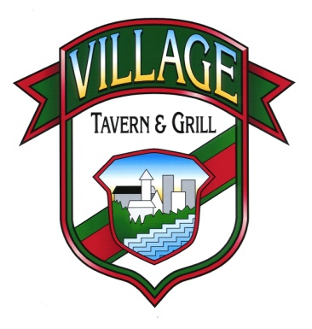

Thank you for considering our “EAT OUT 2 HELP OUT” event to raise funds for your organization. This is part of your EAT OUT 2 HELP OUT packet. You will need to sign the application after securing a date. You will then need to fax or email the application back to us. We have a few suggestions you might want to consider if you are not already utilizing them for your scheduled even. These suggestions include:

- Please make sure you send us the best contact number in order to reach you or someone with your event, that way when we make an event page and put it on our calendar, it will have your contact information for anyone that would like more info concerning your event.
- If you have a Facebook page, we suggest creating an event page. Just click events and follow directions, then share it with your friends and family, while asking them to do the same. If you send us the detailed information on your event we will make an event page on our Facebook page too. The benefit of this is enabling people the ability to print the actual event page as their flyer. You can also share our event page instead of creating your own.
- We suggest saving the date of your EAT OUT 2 HELP OUT event to your Gmail, iCal, or Outlook, then inviting your entire contact list to save the date to their calendar. We will also put it on our website calendar of events.
- If you are going to utilize a group of people to hand out flyers (ex: team, family group, etc.), we suggest you run a contest! Whichever person has the most flyers returned with their name on the back on the day of the event will win whichever type of prize you decide to offer. Encourage them to add it to their Facebook page with the link to the event page!
- NEW: Gift Card donation request. Promote your event by selling our Gift Cards.
Gift cards purchased the day of your event will qualify for the 20% back. Use the link and image below for gift card promotional sales.

The EAT OUT 2 HELP OUT participants that implemented these suggestions literally doubled their income on their events. Some schools/organizations have scheduled monthly EAT OUT 2 HELP OUT events in advance, for example the 1stMonday of every month. This enables everyone to plan accordingly and budgets for your event. Consider booking several events in advance, it requires minimal work if they are already scheduled! Hopefully these suggestions helped!

Best wishes,
Phone: (630)-668-1101
Fax: (630)-668-1113
Email: VTGcarolstream@gmail.com
Website: http://www.villagetavernandgrill.com/home-carol-stream
Don’t forget to visit our Facebook page!
Michael Coughlan
Michael Coughlan

Village Tavern & Grill of Carol Stream
291 South Schmale Road
Carol Stream, IL 60188

Below are some images for you to post on social media and other places online to help promote your event. Gift cards must be purchased the actual day of your scheduled event.

Request Donations:
Use the following link below to direct visitor to purchase the card
http://www.villagetavernandgrill.com/product-page/25-gift-card-1



Village Tavern & Grill Logo
Use the link below to direct people to our website
http://www.villagetavernandgrill.com/home-carol-stream
