Spring/Summer Wednesday League
All participants must fill out the below information to be eligible. They understand that Kippy’s Place does not carry insurance to cover participants in the league. They further release Kippy’s Place of any liability or responsibility due to injuries or losses while participating in league, tournament, and/or open play. Thank you!
League starts on May 24th // Payment due: May 17th
Team Name:

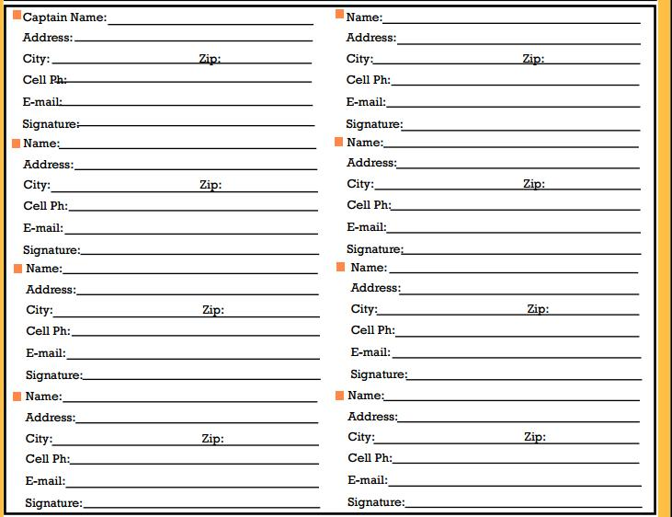Cost per team is $200.00 Form of Payment: Cash Credit/Debit
Date Paid____________ Kippy’s Signature_______________________________
Please return this form to Kippy’s Place, 364 NW Main St, Elkhart 50073

