Project Pizza 2023 Learning Garden Grant

The mission of the Project Pizza Learning Grant is to supply funding to schools and other child-based organizations so they may create a learning garden or expand one that has already been established. The focus of the grant is to increase food literacy in young minds.

Applicants must only apply for this grant if they will serve any nonprofit organization, that serves at least 15 youth between the ages of 2 and 18. This includes public or private schools, or youth programs in Larimer, Boulder, Weld, or Denver Metro Counties in Colorado. Applications are accepted every quarter and end on the last day in March, June, September, and December. The selection of winners is based on demonstrated program impact and sustainability. The grant is $500. For the awardees of the grant and the students involved in the creation and maintenance of the learning garden, Project Pizza will also throw a pizza party at the location of the garden.

Winners will be announced as soon as a decision is made.

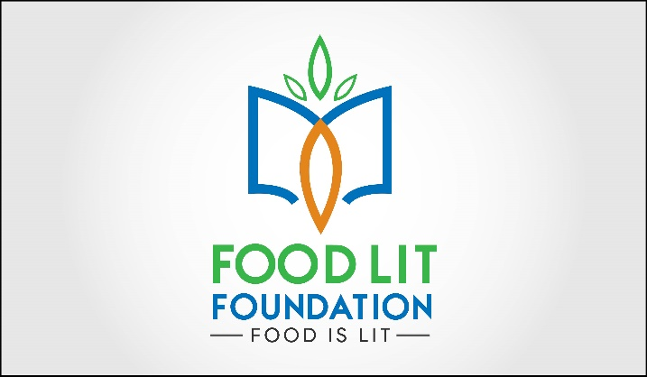

Contact Information

Grant Applicant First Name:

Grant Applicant Last Name:

Grant Applicant Title:

Grant Applicant Email Address (Please note: This is the email address that will receive all grant communications moving forward):

Please confirm the grant applicant’s email address:

Grant Applicant Phone Number:

School/Organization Name:

Garden Program Name (optional):

Location Name (Location of the garden by the official name of the school or facility to receive the award (e.g. "Washington Elementary School," "Fairview Botanical Garden"):

Shipping Address (no P.O. boxes please):

City:

State:

Zip Code:

Has your program applied for Project Pizza’s School Learning Garden Grant before?

Yes
No

Which of the following best describes your organization?

Public School
Private School
Charter School
Nonprofit Agency
Community Garden
Preschool
Head Start
Child Care/Day Care
Garden Club
Summer Camp
YMCA
Boys and Girls Club
Boy Scouts or Girl Scouts
Other: _________________

How many youths from each age group will participate directly in the garden program?

Ages 0-4 (Preschool)
Ages 5-10 (Elementary School)
Ages 11-13 (Middle/Junior High School)
Ages 14-18 (High School)
Ages 18+

If chosen as a winner for the 2023 Project Pizza Learning Garden Grant, will you agree to submit a year-end report with a project summary, photos, and parental photo release forms for recognizable youth featured in images?

Yes
No

Indicate approximately what percentage of your direct program participants identify within the following traditionally under-resourced populations? (Optional)

Children of Migrant Workers
Children of Refugee Families
English Language Learners
Justice-involved Youth
LBTGQ+ Youth
Native American Youth, Hawaiian, or Indigenous Youth
Youth experiencing Homelessness
Youth facing Food Insecurity
Youth from Low Income or Economically Disadvantaged Families
Youth in Foster Care
Youth of Color
Youth of Undocumented Families
Youth with Disabilities
Youth with Special Needs
N/A
Other. Please list:

Garden Program Description

Is your garden program already established (i.e., you have a pre-existing garden or have previously conducted garden programming at your site) or are you just getting started (i.e. you do not have an active garden or garden program at your site)?

New/Start-up Garden Program
Established Garden Program

How many months of the year will you be facilitating garden-based activities?

Provide a concise overview of your garden program’s mission and education goals.

If you are reaching your target audience through alternative hands-on gardening experiences other than a traditional garden space (ie, take-home garden kits, hydroponic units, etc.), please describe here.

How do you plan to sustain your garden program in the future (e.g. ensure ongoing leadership; build partnerships; find sources and/or funds for plant materials, services, tools, etc.)?

Attachments

Optional Letter of Support. Please attach a one-page letter of support for your program written by someone other than the main contact. This letter can be written by an administrator, parent, or community volunteer demonstrating their support of and appreciation for your program.

